M.Zunoorain.Haider 241918 BSCS 5-B FULL STACK WEB DEV LAB 06:

TASK 01:

async function fetchUser(id) {
try {
const response = await fetch(
`https://jsonplaceholder.typicode.com/users/${id}`
);

if (!response.ok) {
throw new Error("Failed to fetch user");
}

const user = await response.json();

if (!user.id || !user.name || !user.email) {
throw new Error("Invalid user object");
}

return user;
} catch (error) {
throw error;
}
}

fetchUser(1)
.then(user => {
console.log("User fetched successfully:");
console.log(user);
})
.catch(error => {
console.log("Error:", error.message);
});
OUTPUT:
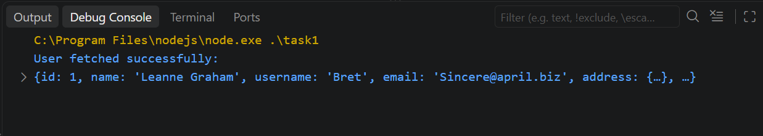
TASK :02

async function fetchUser(id) {
const response = await fetch(
`https://jsonplaceholder.typicode.com/users/${id}`
);

if (!response.ok) {
throw new Error("Failed to fetch user");
}

return response.json();
}

async function fetchPost(id) {
const response = await fetch(
`https://jsonplaceholder.typicode.com/posts/${id}`
);

if (!response.ok) {
throw new Error("Failed to fetch post");
}

return response.json();
}

function fetchBoth(userId, postId) {
return Promise.all([
fetchUser(userId),
fetchPost(postId)
]).then(([user, post]) => {
if (
user.id && user.name && user.email &&
post.id && post.title && post.body
) {
return { user, post };
}

throw new Error("Invalid user or post data");
});
}

fetchBoth(1, 1)
.then(result => {
console.log("Both operations successful:");
console.log(result);
})
.catch(error => {
console.log("Error:", error.message);
});
OUTPUT:
